**Naveen Automation Labs**

API are used when two systems are interacting with each other.

<https://www.youtube.com/watch?v=LUbBkiIhrE4&list=PLFGoYjJG_fqp891lruz5fCRPWsDtEXJky>

WebServices : (MakemyTrip.com)

Api – Web Services 🡺HTTP/network

**Request payload**: In APIs, the payload is the data contained within a request.

Response JSON: Response to a API in JSON format

Response XML: Response to a API in XML format

Authentication : Session/Token ID

Username/ password

Request -JSON/XML

HTTP method – CRUD

SOAP: Simple Object Access Protoco : is a protocoll

Rest : REpresentational State Transfer : is architectural style

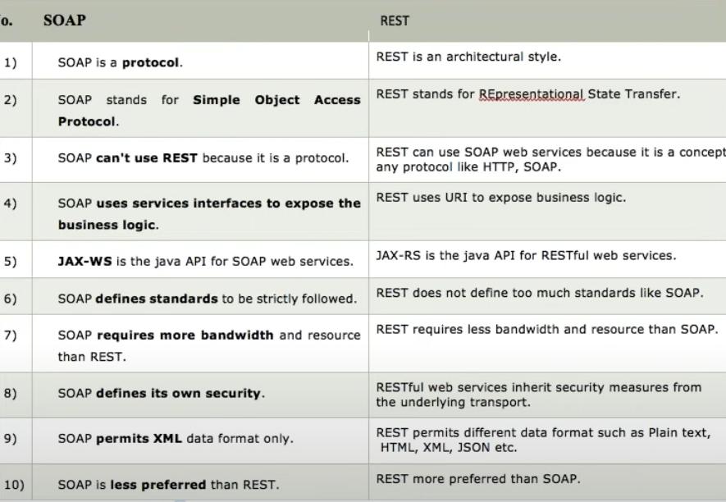

**Rest webservices Automation**

What is Rest Client

HTTP Request = URI +Header + payload (JSON/XML)

HTTP Response = Status + Response payload +String message (successful)

Create Account 🡺POST call 🡺 used to create a new entity 🡺Header +payload

Get an account 🡺GET call 🡺 URI + Path parameter + Query parameter + header

Update account 🡺PUT call 🡺create+ update

Delete Account 🡺DELETE call 🡺

URI = Path parameter +query parameter

HTTP status response codes

<https://developer.mozilla.org/en-US/docs/Web/HTTP/Status>

Status Response code 🡺

200= ok

201 = Created successfully

400 = Bad request

401 = Authentication error

404 = Not found

500 = Server internal error

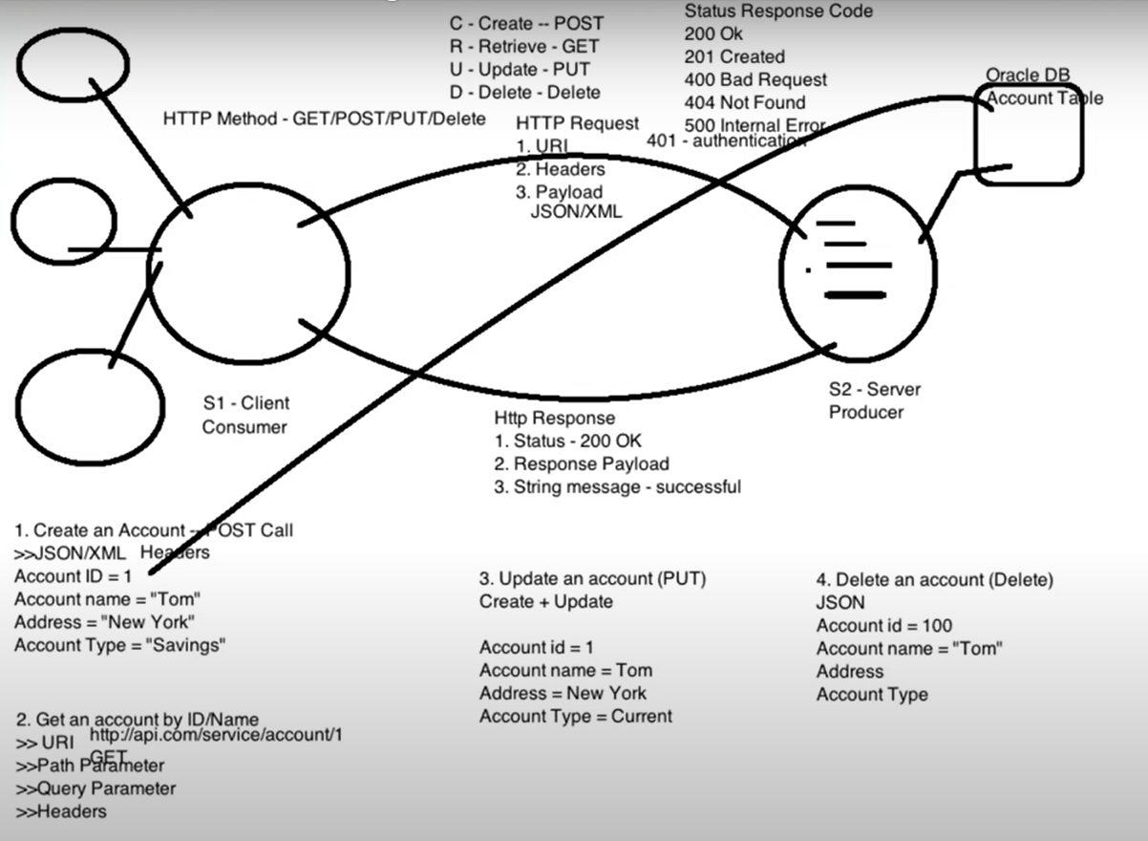

What is postman?

It is a Rest client.

SOAP UI, Advanced Rest Client, JMeter , browser

URL (Endpoint URL + API/Service URL) = URI

Query Paramenter is defined by ?

Path parameter is defined by /

What Is Swagger?

Swagger allows you to describe the structure of your APIs so that machines can read them. The ability of APIs to describe their own structure is the root of all awesomeness in Swagger.

<https://fakerestapi.azurewebsites.net/index.html>

Swagger: Api documentation

Step1

Create maven project

Add dependancies

http client

http core

JSON In Java

TestNG

CloseableHttpResponse : is a Interface

|  |
| --- |
| HttpClients.createDefault() : Create one client connection and returns CloseableHTTPclient object.  **CloseableHttpClient** is the base class of the **httpclient** library, the one all implementations use. |
| HttpGet() : is a class |
| httpClient.execute(httpGet); executes a request or hits the api and returns closeable HTTPResponse |
| httpResponse.getEntity() : Obtains the message entity of this response, if any. The entity is provided by calling setEntity. Returns:the response entity, or null if there is none |
| EntityUtils.toString(httpResponse.getEntity(), "UTF-8" );  EntitiUtils : Static helpers for dealing with [HttpEntity](eclipse-javadoc:%E2%98%82=restapi/C:%5C/Users%5C/TISHAN1KA%5C/.m2%5C/repository%5C/org%5C/apache%5C/httpcomponents%5C/httpcore%5C/4.4.7%5C/httpcore-4.4.7.jar=/maven.pomderived=/true=/=/maven.pomderived=/true=/=/maven.groupId=/org.apache.httpcomponents=/=/maven.artifactId=/httpcore=/=/maven.version=/4.4.7=/=/maven.scope=/compile=/%3Corg.apache.http.util(EntityUtils.class%E2%98%83EntityUtils%E2%98%82HttpEntity)s. |
| JSON obj = new JSONObject(responseString)  Converts Response to JSON Object |
|  |
|  |
|  |
|  |
|  |
|  |
|  |
|  |
|  |

Add dependancy in pom.xml :

Jackson Databind

**HTTP Client**

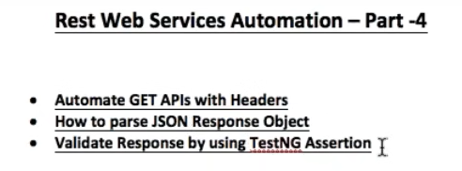

RestClient.java

|  |
| --- |
| //get method without headers  public CloseableHttpResponse get(String url) throws ClientProtocolException, IOException {  CloseableHttpClient httpClient = HttpClients.createDefault();  HttpGet httpGet = new HttpGet(url); // http get request  CloseableHttpResponse closeableHttpResponse = httpClient.execute(httpGet); // hit the URL  return closeableHttpResponse;  } |

|  |
| --- |
| package com.qa.tests;  import java.io.File;  import java.io.IOException;  import java.util.HashMap;  import org.apache.http.Header;  import org.apache.http.client.ClientProtocolException;  import org.apache.http.client.methods.CloseableHttpResponse;  import org.apache.http.util.EntityUtils;  import org.json.JSONObject;  import org.testng.Assert;  //import org.junit.Assert;  import org.testng.annotations.BeforeMethod;  import org.testng.annotations.Test;  import com.fasterxml.jackson.core.JsonGenerationException;  import com.fasterxml.jackson.databind.JsonMappingException;  import com.fasterxml.jackson.databind.ObjectMapper;  import com.qa.base.TestBase;  import com.qa.client.RestClient;  import com.qa.data.Users;  public class PostApiTest extends TestBase {  TestBase testBase ;  String mainUrl ;  String apiUrl ;  String url ;  RestClient restClient;  **PostAPITest.java**  CloseableHttpResponse closeableHttpResponse;    @BeforeMethod  public void setUp() throws ClientProtocolException, IOException {  System.out.println("GetAPITest ==> @BeforeMethod ==> setUp");  testBase = new TestBase();  mainUrl = prop.getProperty("url");  apiUrl =prop.getProperty("serviceurl");  url = mainUrl + apiUrl;  }    @Test  public void postAPITest() throws JsonGenerationException, JsonMappingException, IOException {  restClient= new RestClient();  HashMap <String, String> headerMap = new HashMap<String , String>();  headerMap.put("Content-Type", "application/json");    ObjectMapper mapper = new ObjectMapper();  Users users= new Users("morpheus" , "leader");    String filePath1 = "C:\\Users\\TISHAN1KA\\eclipse-workspace\\restapi\\src\\main\\java\\com\\qa\\data\\users.json";    //System.out.println(filePath1);    //This is marshalling ==> java to Json  //Object to json File  mapper.writeValue(new File(filePath1), users);    //Object to json String  String userJsonString = mapper.writeValueAsString(users);  //System.out.println("userJsonString = " + userJsonString);  closeableHttpResponse = restClient.postUser(url, userJsonString, headerMap);      //get Status code  int statusCode = closeableHttpResponse.getStatusLine().getStatusCode();  Assert.assertEquals( statusCode , testBase.Response_Code_201);    //Json String  String responseString = EntityUtils.toString(closeableHttpResponse.getEntity(), "UTF-8");  System.out.println("responseString = " + responseString);    JSONObject responseJson = new JSONObject(responseString);  System.out.println("responseJson = " + responseJson);    //This is unmarshalling ==>json to java  //json to java object  Users userResObj = mapper.readValue(responseString, Users.class); //actual user object  System.out.println(userResObj);    Assert.assertTrue(users.getName().equals(userResObj.getName()));  Assert.assertTrue(users.getJob().equals(userResObj.getJob()) );  System.out.println(userResObj.getId());  System.out.println(userResObj.getCreatedAt());  }    } |

|  |
| --- |
| **TestUtil.java**  package com.qa.util;  import org.json.JSONArray;  import org.json.JSONObject;  public class TestUtil {    public static JSONObject responsejson;      public static String getValueByJPath(JSONObject responsejson, String jpath){  Object obj = responsejson;    for(String s : jpath.split("/"))  if(!s.isEmpty())  if(!(s.contains("[") || s.contains("]")))  obj = ((JSONObject) obj).get(s);  else if(s.contains("[") || s.contains("]"))  obj = ((JSONArray) ((JSONObject) obj).get(s.split("\\[")[0])).get(Integer.parseInt(s.split("\\[")[1].replace("]", "")));  return obj.toString();  }  } |

https://rahulshettyacademy.com/RS8161114

HTTPPost

Create client

Create request

Add payload

Add headers

Execute the request

Create post call

Call API

Perform marshalling

Call the postAPI

Validate response

Steps

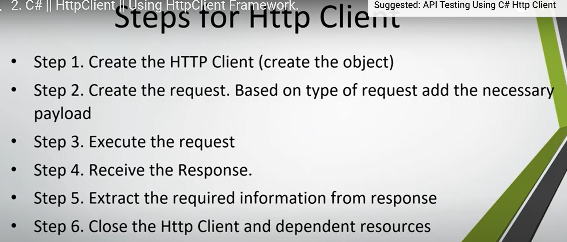

Get Method

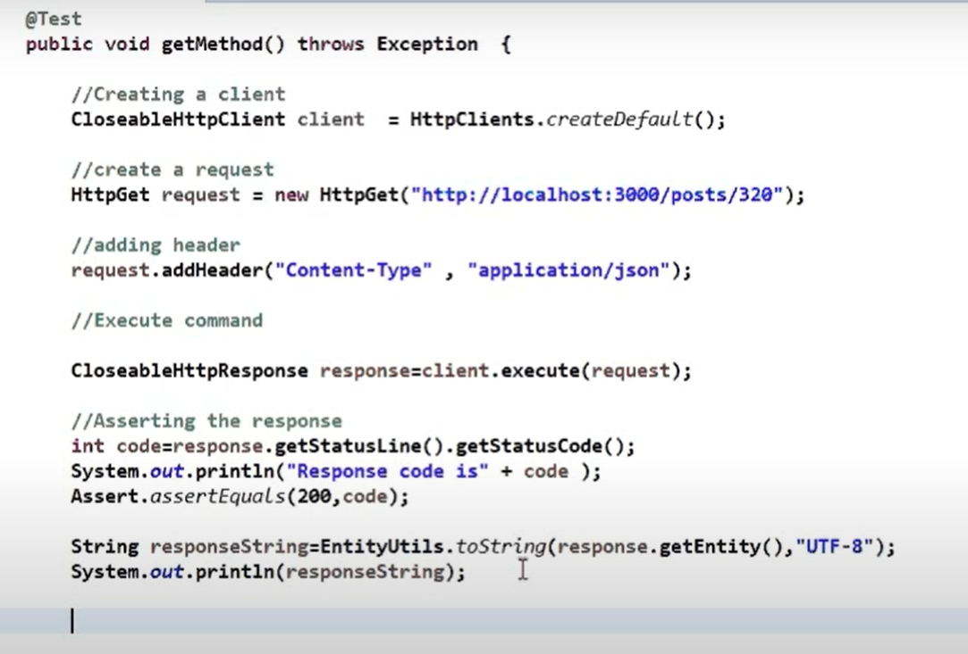

Post Method

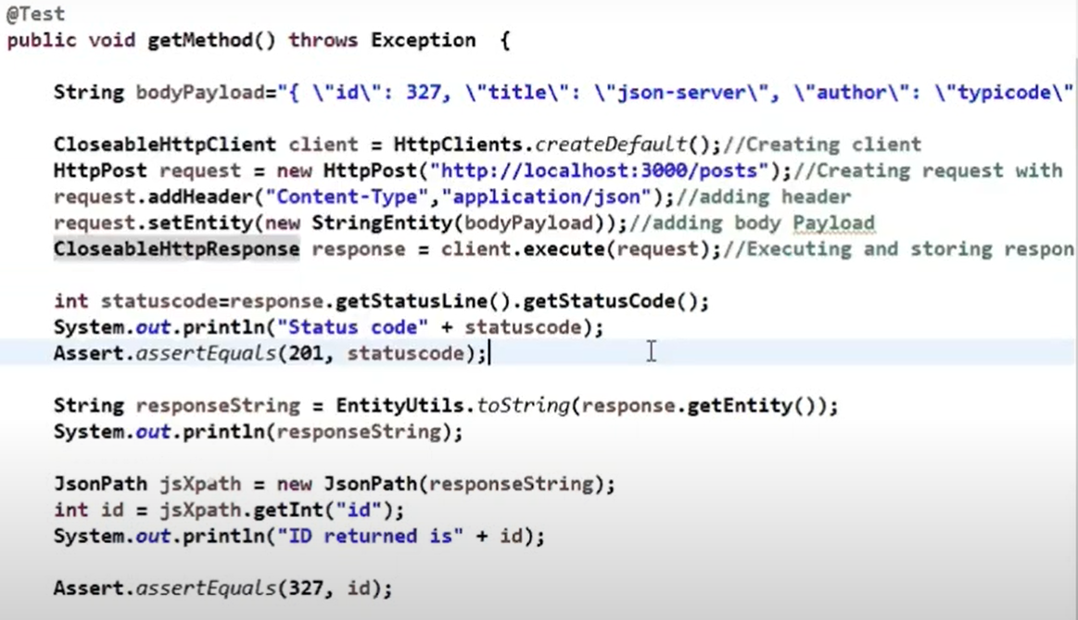

*Whenever there is a pay load create a equivalent java class (POJO class)

============================

POJO class: Plain Old Java Object

Marshalling:

Marshalling is the process of writing Java objects to XML file. Unmarshalling is the process of converting XML content to Java objects. Create Java Application client (main ())

Marshalling is a technique that can be easily understood and utilized efficiently. IT is the process of converting a POJO(Plain Old Java Object) in memory into a format that can be written to disk or send via network, usually in text formats like xml or json. The reverse of this technique is called unmarshalling.

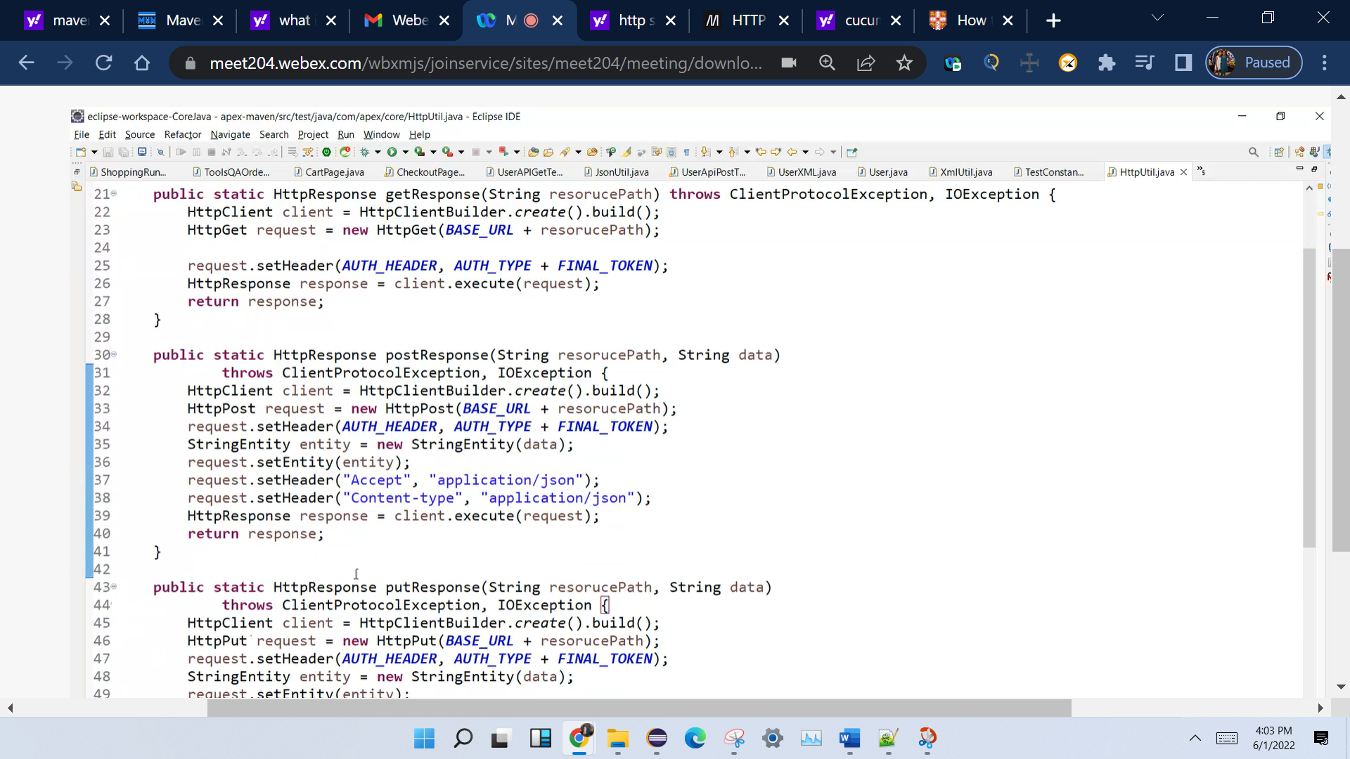

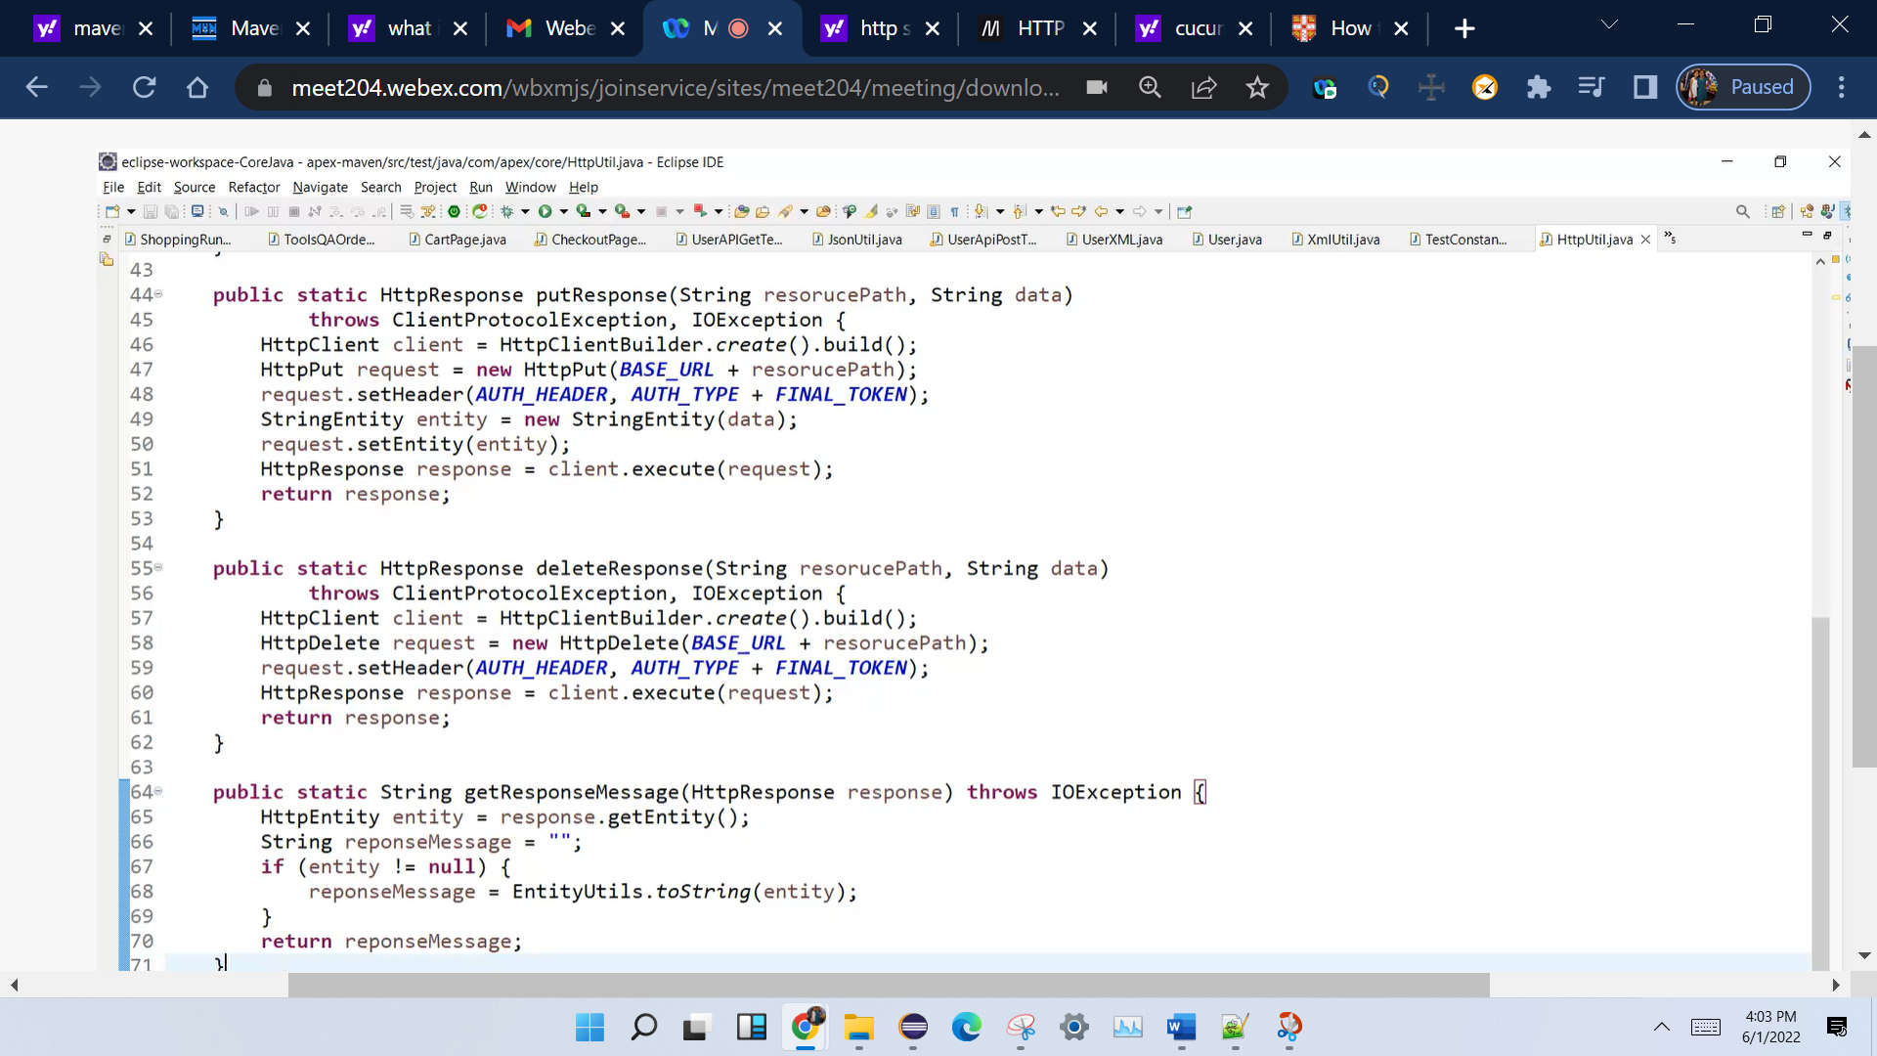

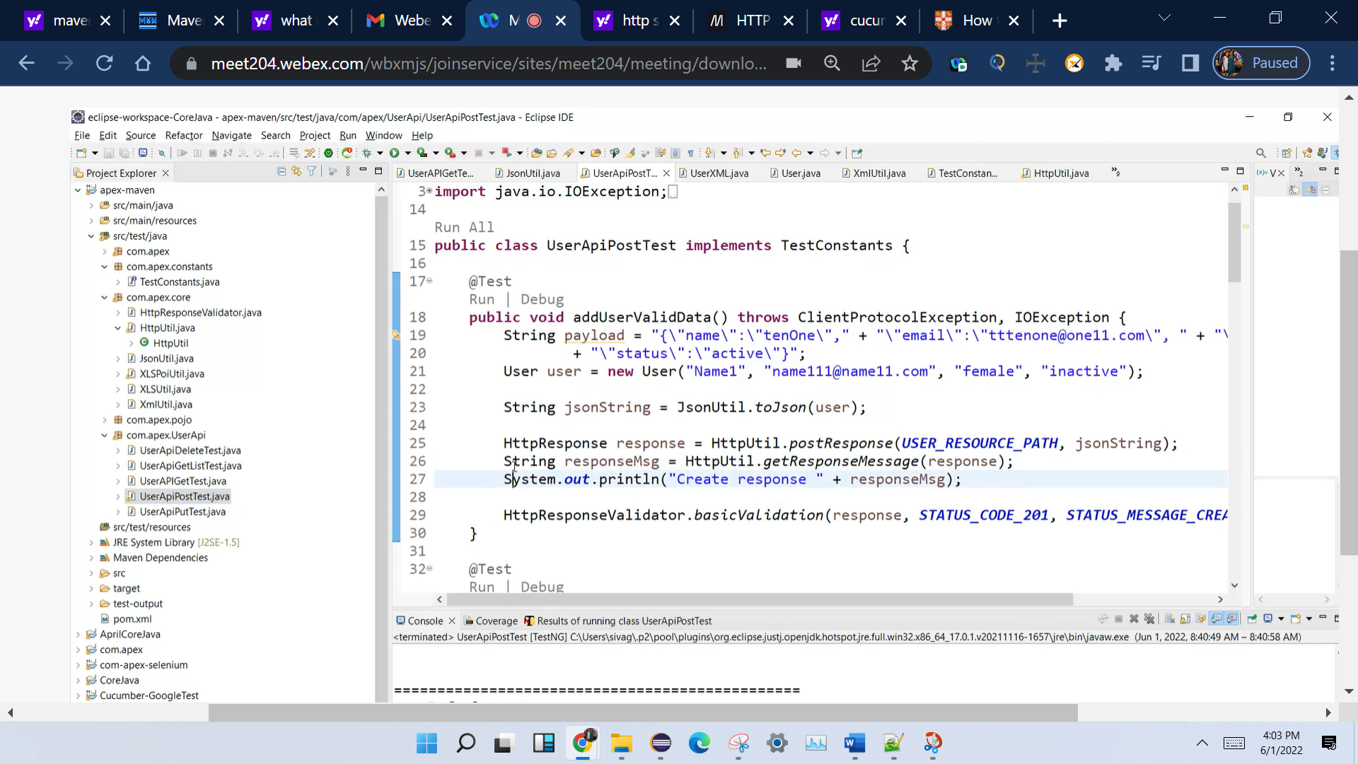

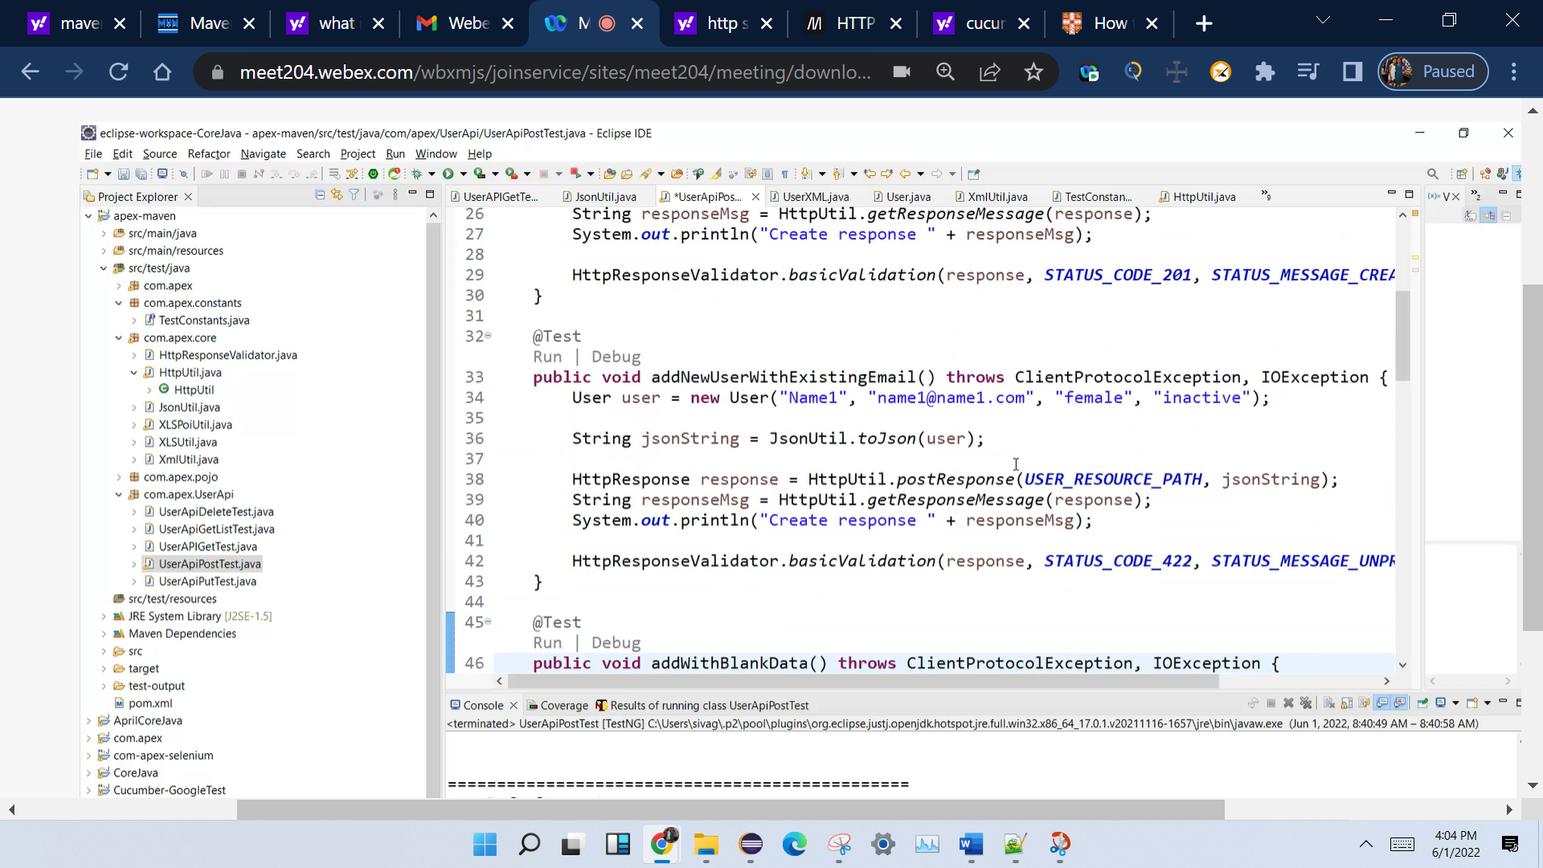

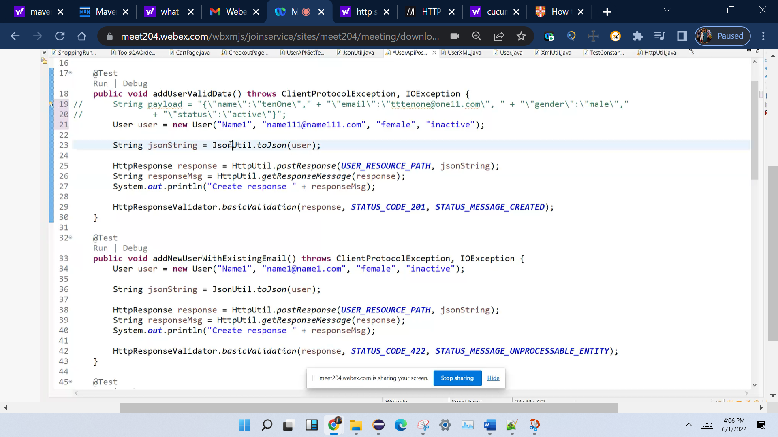

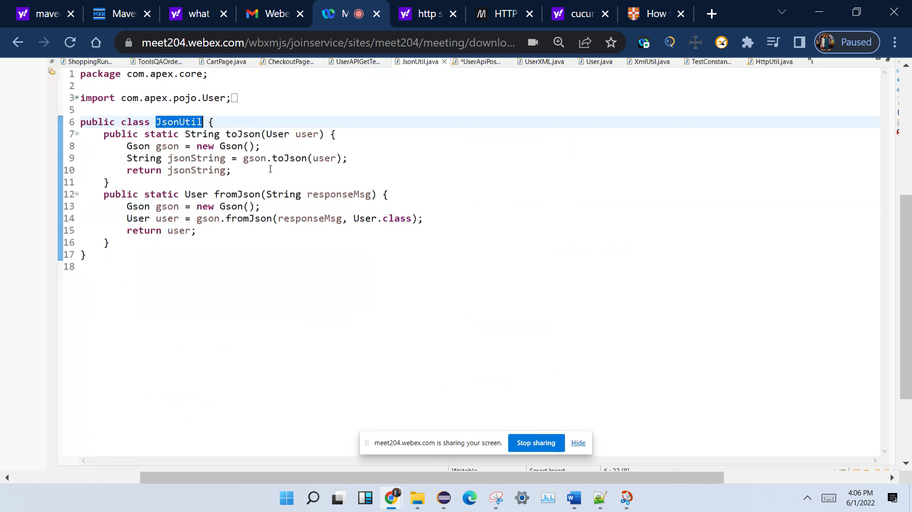

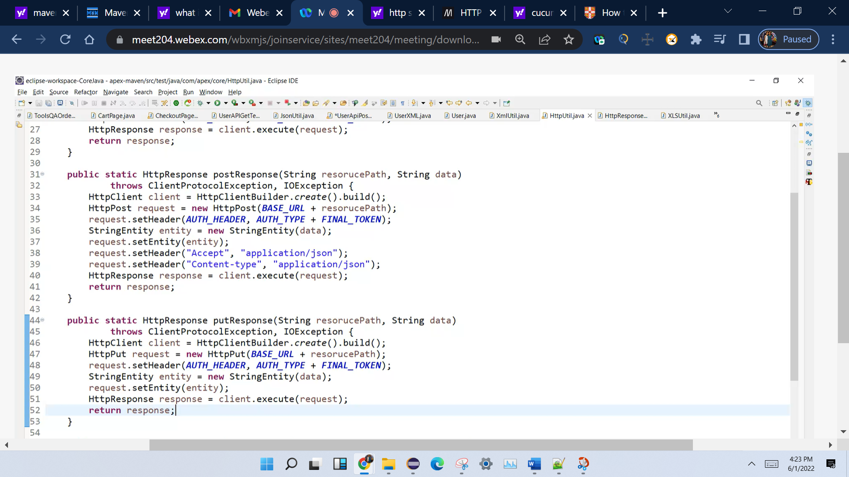

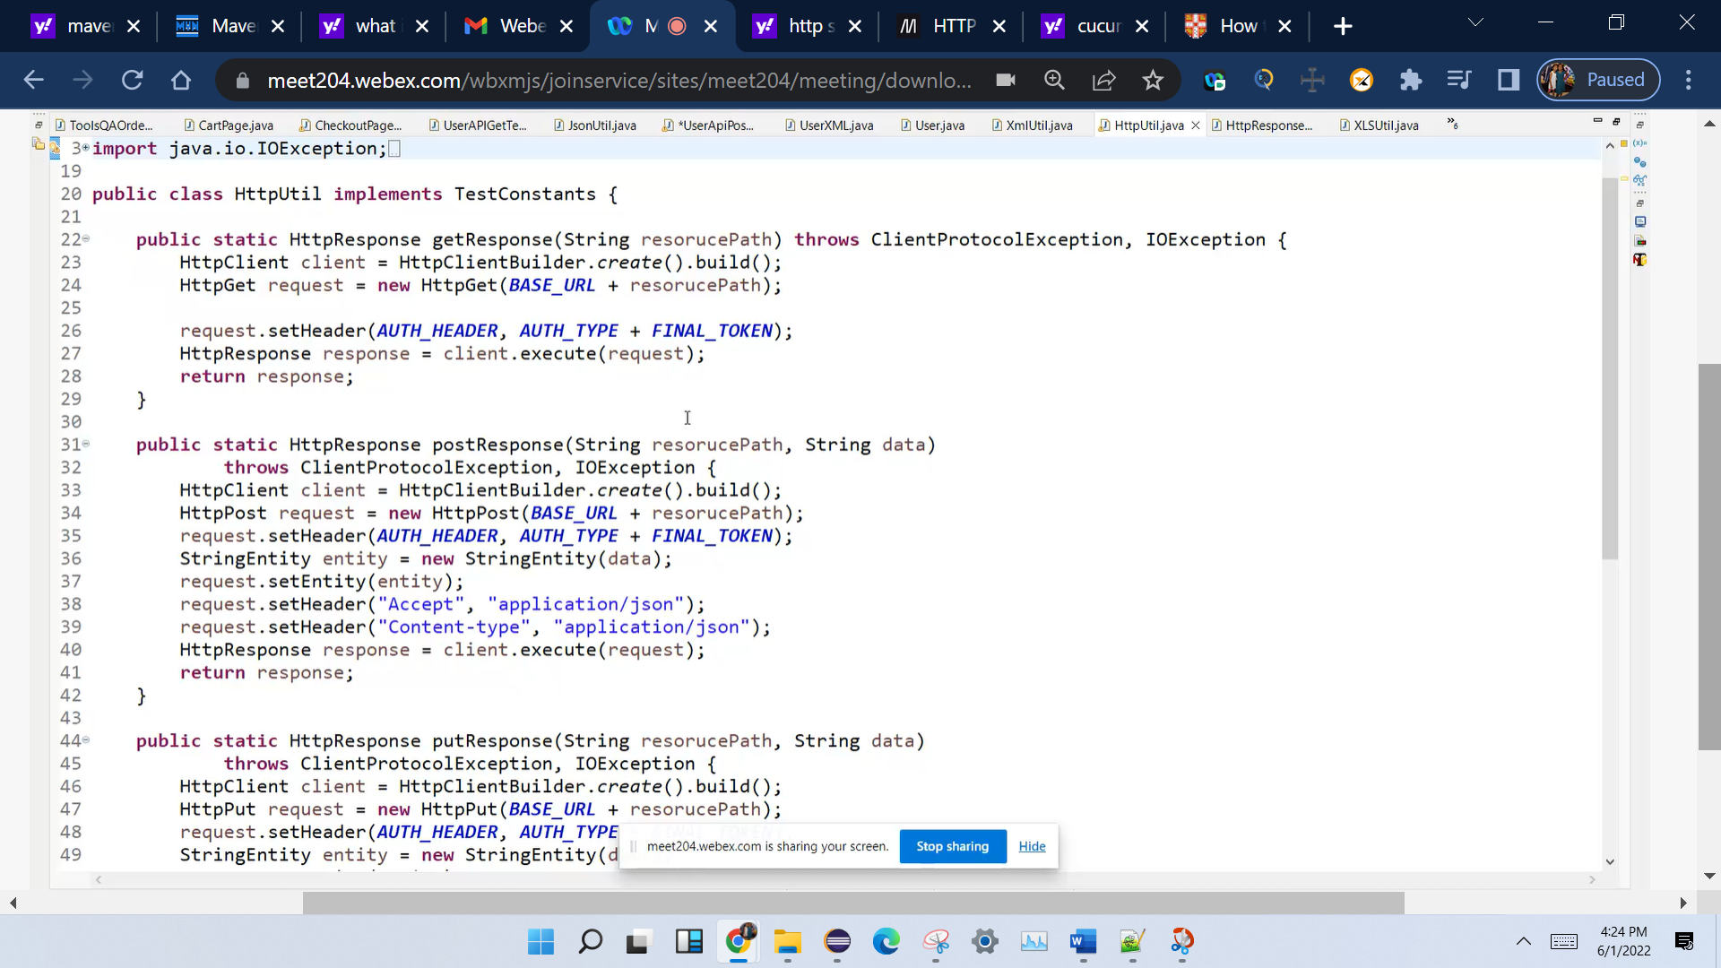

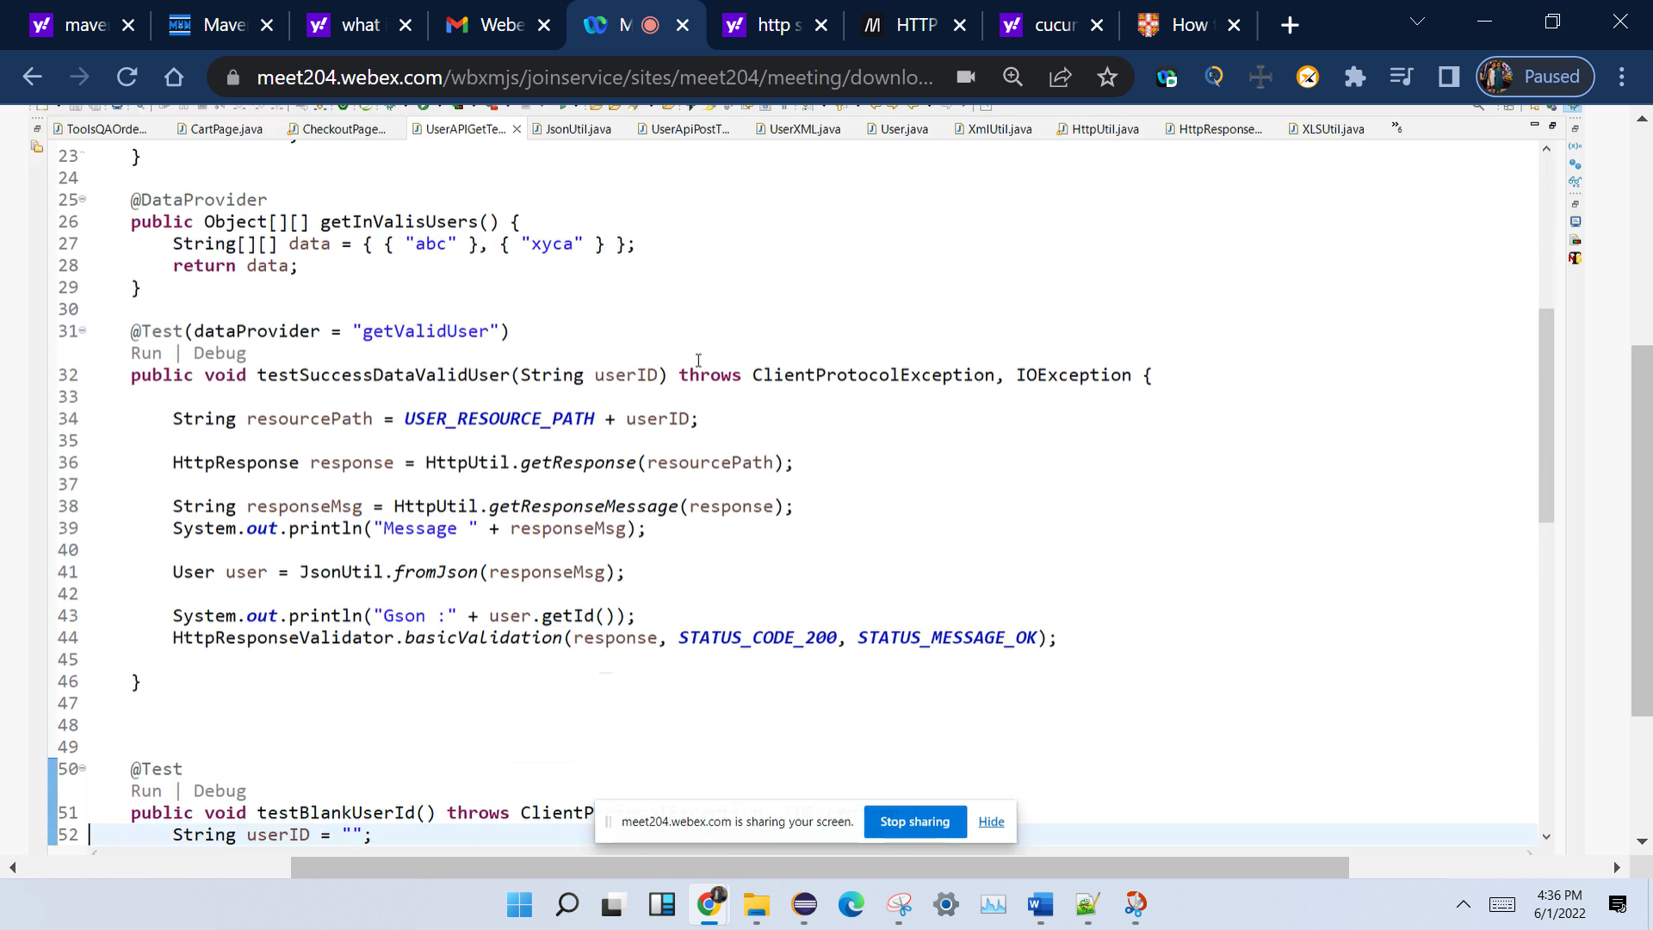

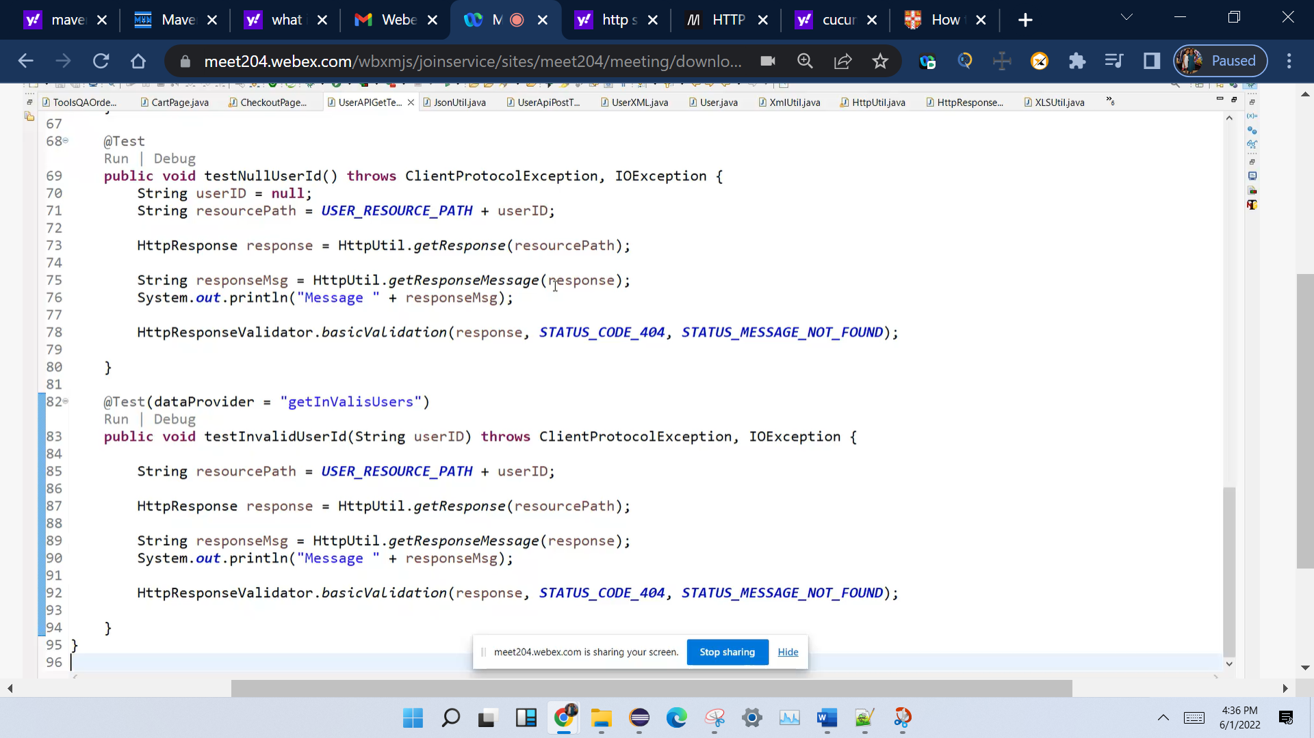

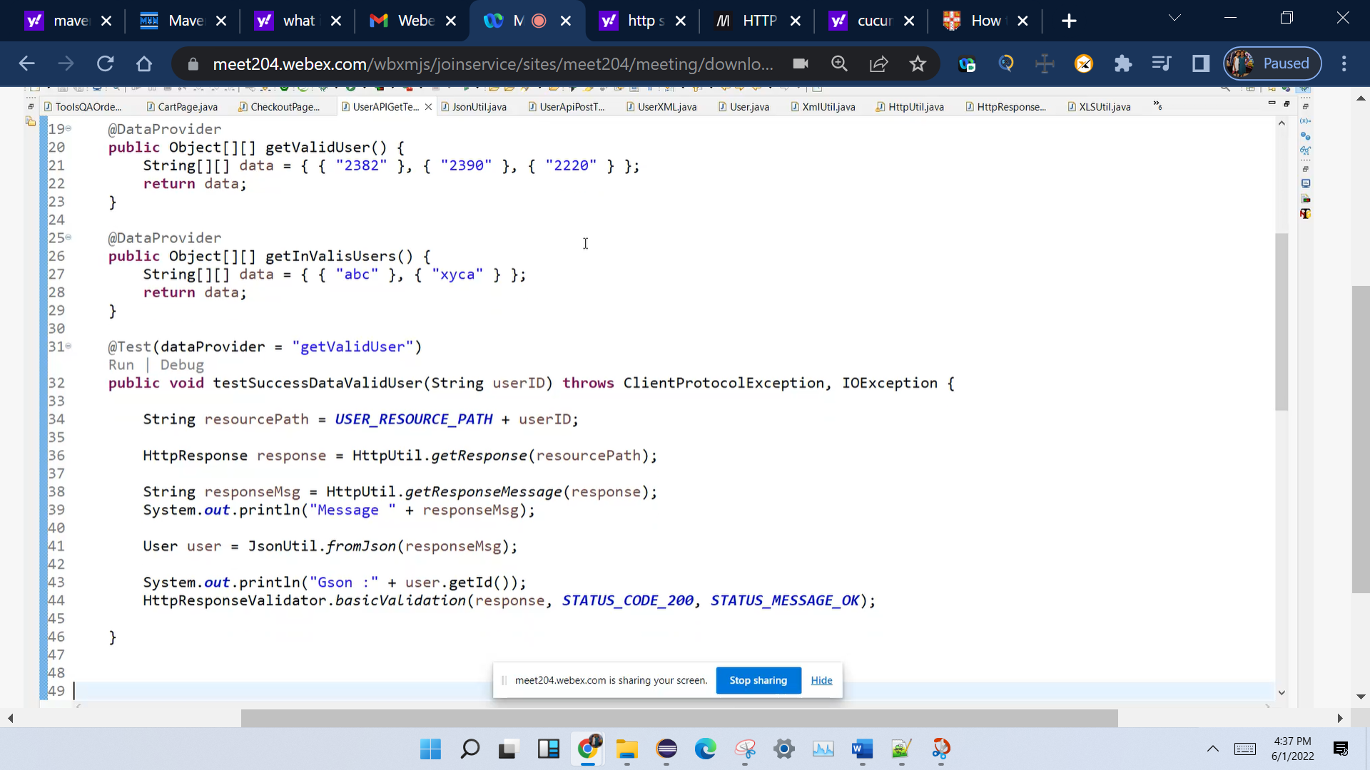

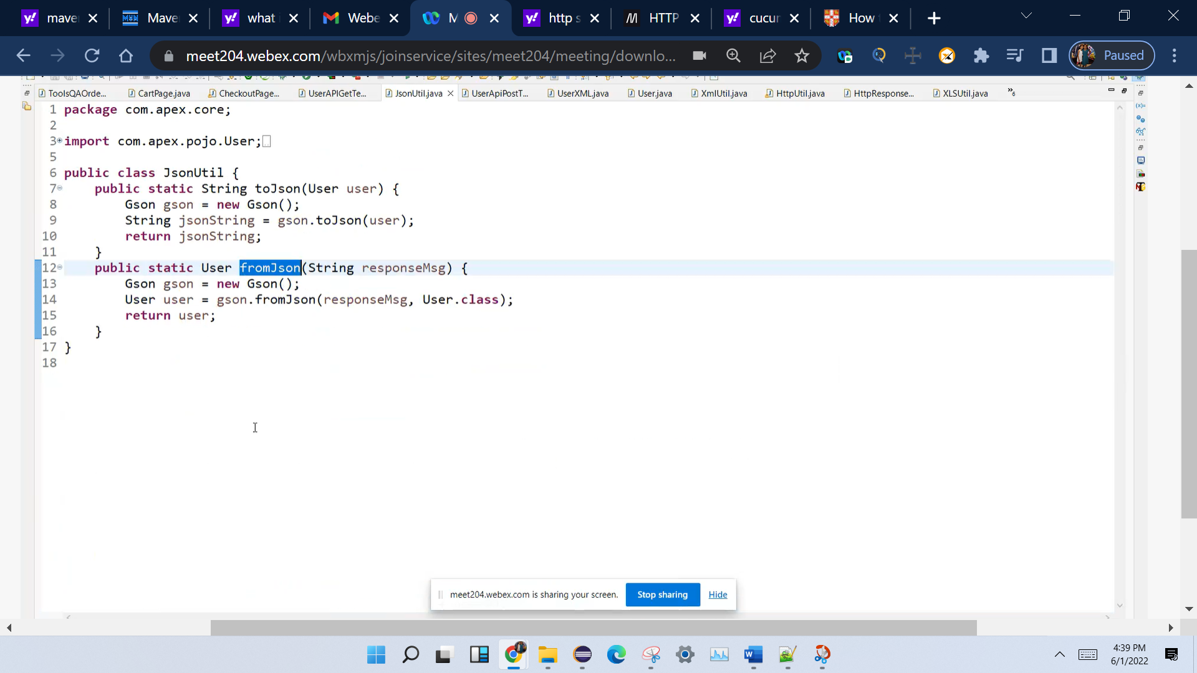

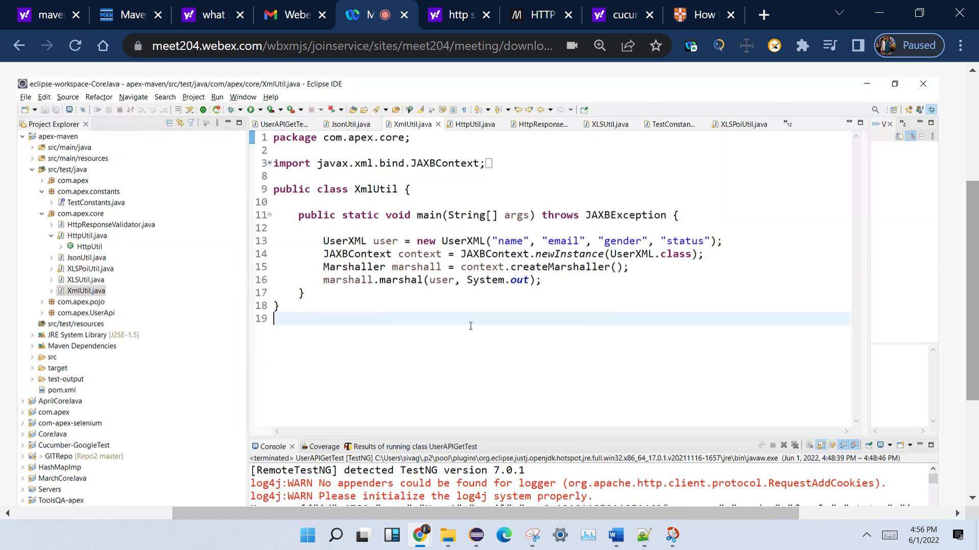

Marsheller vs unmarshalling

Start Mkyong.com

This article shows you how to use [Apache HttpClient](https://hc.apache.org/httpcomponents-client-4.5.x/index.html) to send an HTTP GET/POST requests, JSON, authentication, timeout, redirection and some frequent used examples.

P.S Tested with HttpClient 4.5.10

|  |
| --- |
| pom.xml  <dependency>  <groupId>org.apache.httpcomponents</groupId>  <artifactId>httpclient</artifactId>  <version>4.5.10</version>  </dependency> |

## 1. Send GET Request

1.1 Close manually.

|  |
| --- |
| HttpClientExample1_1.java  package com.mkyong.http;  import org.apache.http.HttpEntity;  import org.apache.http.HttpHeaders;  import org.apache.http.client.methods.CloseableHttpResponse;  import org.apache.http.client.methods.HttpGet;  import org.apache.http.impl.client.CloseableHttpClient;  import org.apache.http.impl.client.HttpClients;  import org.apache.http.util.EntityUtils;  import java.io.IOException;  public class HttpClientExample1_1 {  public static void main(String[] args) throws IOException {  CloseableHttpClient httpClient = HttpClients.createDefault();  try {  HttpGet request = new HttpGet("https://httpbin.org/get");  // add request headers  request.addHeader("custom-key", "mkyong");  request.addHeader(HttpHeaders.USER_AGENT, "Googlebot");  CloseableHttpResponse response = httpClient.execute(request);  try {  // Get HttpResponse Status  System.out.println(response.getProtocolVersion()); // HTTP/1.1  System.out.println(response.getStatusLine().getStatusCode()); // 200  System.out.println(response.getStatusLine().getReasonPhrase()); // OK  System.out.println(response.getStatusLine().toString()); // HTTP/1.1 200 OK  HttpEntity entity = response.getEntity();  if (entity != null) {  // return it as a String  String result = EntityUtils.toString(entity);  System.out.println(result);  }  } finally {  response.close();  }  } finally {  httpClient.close();  }  } |

1.2 Close with try-with-resources.

|  |
| --- |
| HttpClientExample1_2.java  package com.mkyong.http;  import org.apache.http.HttpEntity;  import org.apache.http.HttpHeaders;  import org.apache.http.client.methods.CloseableHttpResponse;  import org.apache.http.client.methods.HttpGet;  import org.apache.http.impl.client.CloseableHttpClient;  import org.apache.http.impl.client.HttpClients;  import org.apache.http.util.EntityUtils;  import java.io.IOException;  public class HttpClientExample1_2 {  public static void main(String[] args) throws IOException {  HttpGet request = new HttpGet("https://httpbin.org/get");  // add request headers  request.addHeader("custom-key", "mkyong");  request.addHeader(HttpHeaders.USER_AGENT, "Googlebot");  try (CloseableHttpClient httpClient = HttpClients.createDefault();  CloseableHttpResponse response = httpClient.execute(request)) {  // Get HttpResponse Status  System.out.println(response.getProtocolVersion()); // HTTP/1.1  System.out.println(response.getStatusLine().getStatusCode()); // 200  System.out.println(response.getStatusLine().getReasonPhrase()); // OK  System.out.println(response.getStatusLine().toString()); // HTTP/1.1 200 OK  HttpEntity entity = response.getEntity();  if (entity != null) {  // return it as a String  String result = EntityUtils.toString(entity);  System.out.println(result);  }  }  } |

## 2. Send Normal POST Request

|  |
| --- |
| HttpClientExample2_1.java  package com.mkyong.http;  import org.apache.http.HttpHeaders;  import org.apache.http.NameValuePair;  import org.apache.http.client.entity.UrlEncodedFormEntity;  import org.apache.http.client.methods.CloseableHttpResponse;  import org.apache.http.client.methods.HttpGet;  import org.apache.http.client.methods.HttpPost;  import org.apache.http.impl.client.CloseableHttpClient;  import org.apache.http.impl.client.HttpClients;  import org.apache.http.message.BasicNameValuePair;  import org.apache.http.util.EntityUtils;  import java.io.BufferedReader;  import java.io.IOException;  import java.io.InputStreamReader;  import java.util.ArrayList;  import java.util.List;  public class HttpClientExample2_1 {  public static void main(String[] args) {  try {  String result = sendPOST("https://httpbin.org/post");  System.out.println(result);  } catch (IOException e) {  e.printStackTrace();  }  }  private static String sendPOST(String url) throws IOException {  String result = "";  HttpPost post = new HttpPost(url);  // add request parameters or form parameters  List<NameValuePair> urlParameters = new ArrayList<>();  urlParameters.add(new BasicNameValuePair("username", "abc"));  urlParameters.add(new BasicNameValuePair("password", "123"));  urlParameters.add(new BasicNameValuePair("custom", "secret"));  post.setEntity(new UrlEncodedFormEntity(urlParameters));  try (CloseableHttpClient httpClient = HttpClients.createDefault();  CloseableHttpResponse response = httpClient.execute(post)){  result = EntityUtils.toString(response.getEntity());  }  return result;  } |

## 3. Send JSON POST Request

3.1 Send a POST request with JSON formatted data. The key is passed the JSON formatted date into a StringEntity.

|  |
| --- |
| HttpClientExample3_1.java  package com.mkyong.http;  import org.apache.http.client.methods.CloseableHttpResponse;  import org.apache.http.client.methods.HttpPost;  import org.apache.http.entity.StringEntity;  import org.apache.http.impl.client.CloseableHttpClient;  import org.apache.http.impl.client.HttpClients;  import org.apache.http.util.EntityUtils;  import java.io.IOException;  public class HttpClientExample3_1 {  public static void main(String[] args) {  try {  String result = sendPOST("https://httpbin.org/post");  System.out.println(result);  } catch (IOException e) {  e.printStackTrace();  }  }  private static String sendPOST(String url) throws IOException {  String result = "";  HttpPost post = new HttpPost(url);  StringBuilder json = new StringBuilder();  json.append("{");  json.append("\"name\":\"mkyong\",");  json.append("\"notes\":\"hello\"");  json.append("}");  // send a JSON data  post.setEntity(new StringEntity(json.toString()));  try (CloseableHttpClient httpClient = HttpClients.createDefault();  CloseableHttpResponse response = httpClient.execute(post)) {  result = EntityUtils.toString(response.getEntity());  }  return result;  }  } |

3.2 Send a POST request to Cloudflare API to block an IP address. Authentication in headers.

|  |
| --- |
| HttpClientExample3_2.java  package com.mkyong.http;  import org.apache.http.client.methods.CloseableHttpResponse;  import org.apache.http.client.methods.HttpPost;  import org.apache.http.entity.StringEntity;  import org.apache.http.impl.client.CloseableHttpClient;  import org.apache.http.impl.client.HttpClients;  import org.apache.http.util.EntityUtils;  import java.io.IOException;  public class HttpClientExample3_2 {  public static void main(String[] args) {  try {  String result = blockIP("1.1.1.1");  System.out.println(result);  } catch (IOException e) {  e.printStackTrace();  }  }  private static String blockIP(String ip) throws IOException {  String result = "";  HttpPost post = new HttpPost("https://api.cloudflare.com/client/v4/user/firewall/access_rules/rules");  post.addHeader("content-type", "application/json");  post.addHeader("X-Auth-Email", "email");  post.addHeader("X-Auth-Key", "token123");  String block = "{\"target\":\"ip\",\"value\":\"" + ip + "\"}";  StringBuilder entity = new StringBuilder();  entity.append("{");  entity.append("\"mode\":\"block\",");  entity.append("\"configuration\":" + block + ",");  entity.append("\"notes\":\"hello\"");  entity.append("}");  // send a JSON data  post.setEntity(new StringEntity(entity.toString()));  try (CloseableHttpClient httpClient = HttpClients.createDefault();  CloseableHttpResponse response = httpClient.execute(post)) {  result = EntityUtils.toString(response.getEntity());  }  return result;  }  } |

## 4. HTTP Basic Authentication

|  |
| --- |
| HttpClientExample4_1.java  package com.mkyong.http;  import org.apache.http.HttpEntity;  import org.apache.http.auth.AuthScope;  import org.apache.http.auth.UsernamePasswordCredentials;  import org.apache.http.client.CredentialsProvider;  import org.apache.http.client.methods.CloseableHttpResponse;  import org.apache.http.client.methods.HttpGet;  import org.apache.http.impl.client.BasicCredentialsProvider;  import org.apache.http.impl.client.CloseableHttpClient;  import org.apache.http.impl.client.HttpClientBuilder;  import org.apache.http.util.EntityUtils;  import java.io.IOException;  public class HttpClientExample4_1 {  public static void main(String[] args) throws IOException {  HttpGet request = new HttpGet("http://localhost:8080/books");  CredentialsProvider provider = new BasicCredentialsProvider();  provider.setCredentials(  AuthScope.ANY,  new UsernamePasswordCredentials("user", "password")  );  try (CloseableHttpClient httpClient = HttpClientBuilder.create()  .setDefaultCredentialsProvider(provider)  .build();  CloseableHttpResponse response = httpClient.execute(request)) {  // 401 if wrong user/password  System.out.println(response.getStatusLine().getStatusCode());  HttpEntity entity = response.getEntity();  if (entity != null) {  // return it as a String  String result = EntityUtils.toString(entity);  System.out.println(result);  }  }  } |

}

Read this – [Apache HttpClient Basic Authentication Examples](https://www.mkyong.com/java/apache-httpclient-basic-authentication-examples/)

## 5. FAQs

5.1 Disabled Redirect.

|  |
| --- |
| HttpClientExample5_1.java  package com.mkyong.customer;  import org.apache.http.HttpEntity;  import org.apache.http.HttpHeaders;  import org.apache.http.client.methods.CloseableHttpResponse;  import org.apache.http.client.methods.HttpGet;  import org.apache.http.impl.client.CloseableHttpClient;  import org.apache.http.impl.client.HttpClientBuilder;  import org.apache.http.util.EntityUtils;  import java.io.IOException;  public class HttpClientExample5_1 {  public static void main(String[] args) throws IOException {  HttpGet request = new HttpGet("https://t.co/calv72DH8f");  request.addHeader(HttpHeaders.USER_AGENT, "Googlebot");  try (CloseableHttpClient httpClient = HttpClientBuilder.create().disableRedirectHandling().build();  CloseableHttpResponse response = httpClient.execute(request)) {  // Get HttpResponse Status  System.out.println(response.getProtocolVersion()); // HTTP/1.1  System.out.println(response.getStatusLine().getStatusCode()); // 301  System.out.println(response.getStatusLine().getReasonPhrase()); // Moved Permanently  System.out.println(response.getStatusLine().toString()); // HTTP/1.1 301 Moved Permanently  HttpEntity entity = response.getEntity();  if (entity != null) {  // return it as a String  String result = EntityUtils.toString(entity);  System.out.println(result);  }  }  } |

5.2 Connection time out on request level.

|  |
| --- |
| HttpGet request = new HttpGet("https://httpbin.org/get");  // 5 seconds timeout  RequestConfig requestConfig = RequestConfig.custom()  .setConnectionRequestTimeout(5000)  .setConnectTimeout(5000)  .setSocketTimeout(5000)  .build();  request.setConfig(requestConfig);  try (CloseableHttpClient httpClient = HttpClients.createDefault();  CloseableHttpResponse response = httpClient.execute(request)) {  //...  }  5.3 Connection time out on client level.  HttpGet request = new HttpGet("https://httpbin.org/get");  // 5 seconds timeout  RequestConfig requestConfig = RequestConfig.custom()  .setConnectionRequestTimeout(5000)  .setConnectTimeout(5000)  .setSocketTimeout(5000)  .build();  //request.setConfig(requestConfig);  try (CloseableHttpClient httpClient = HttpClientBuilder.create()  .setDefaultRequestConfig(requestConfig)  .build();  CloseableHttpResponse response = httpClient.execute(request)) {  //...  }  5.4 Configure a proxy server. Read HttpClient proxy configuration  HttpGet request = new HttpGet("https://httpbin.org/get");  RequestConfig requestConfig = RequestConfig.custom()  .setProxy(new HttpHost("company.proxy.url", 8080))  .build();  request.setConfig(requestConfig);  try (CloseableHttpClient httpClient = HttpClients.createDefault();  CloseableHttpResponse response = httpClient.execute(request)) {  //...  }  5.5 Turn on cookie. Read HTTP cookies  HttpGet request = new HttpGet("https://httpbin.org/get");    RequestConfig requestConfig = RequestConfig.custom()  .setCookieSpec(CookieSpecs.DEFAULT)  .build();  request.setConfig(requestConfig);    try (CloseableHttpClient httpClient = HttpClients.createDefault();  CloseableHttpResponse response = httpClient.execute(request)) {  //...  }  5.6 Get response header and also the media type.  try (CloseableHttpClient httpClient = HttpClients.createDefault();  CloseableHttpResponse response = httpClient.execute(request)) {  HttpEntity entity = response.getEntity();  Header headers = entity.getContentType();  System.out.println(headers);  //...  }  Sample  Content-Type: application/json  {  "args": {},  "headers": {  "Accept-Encoding": "gzip,deflate",  "Custom-Key": "mkyong",  "Host": "httpbin.org",  "User-Agent": "Googlebot"  },  "origin": "202.168.71.227, 202.168.71.227",  "url": "https://httpbin.org/get"  } |

## References

* [Apache HttpClient](https://hc.apache.org/httpcomponents-client-4.5.x/index.html)
* [HttpClient Tutorial](https://hc.apache.org/httpcomponents-client-4.5.x/tutorial/html/index.html)
* [Apache HttpClient Basic Authentication Examples](https://www.mkyong.com/java/apache-httpclient-basic-authentication-examples/)

In this article, we will show you a few examples to make HTTP GET/POST requests via the following APIs

Apache HttpClient 4.5.10

OkHttp 4.2.2

Java 11 HttpClient

Java 1.1 HttpURLConnection (Not recommend)

1. Apache HttpClient

In the old days, this Apache HttpClient is the de facto standard to send an HTTP GET/POST request in Java.

pom.xml

<dependency>

<groupId>org.apache.httpcomponents</groupId>

<artifactId>httpclient</artifactId>

<version>4.5.10</version>

</dependency>

HttpClientExample.java

package com.mkyong.http;

import org.apache.http.Header;

import org.apache.http.HttpEntity;

import org.apache.http.HttpHeaders;

import org.apache.http.NameValuePair;

import org.apache.http.client.entity.UrlEncodedFormEntity;

import org.apache.http.client.methods.CloseableHttpResponse;

import org.apache.http.client.methods.HttpGet;

import org.apache.http.client.methods.HttpPost;

import org.apache.http.impl.client.CloseableHttpClient;

import org.apache.http.impl.client.HttpClients;

import org.apache.http.message.BasicNameValuePair;

import org.apache.http.util.EntityUtils;

import java.io.IOException;

import java.util.ArrayList;

import java.util.List;

public class HttpClientExample {

// one instance, reuse

private final CloseableHttpClient httpClient = HttpClients.createDefault();

public static void main(String[] args) throws Exception {

HttpClientExample obj = new HttpClientExample();

try {

System.out.println("Testing 1 - Send Http GET request");

obj.sendGet();

System.out.println("Testing 2 - Send Http POST request");

obj.sendPost();

} finally {

obj.close();

}

}

private void close() throws IOException {

httpClient.close();

}

private void sendGet() throws Exception {

HttpGet request = new HttpGet("https://www.google.com/search?q=mkyong");

// add request headers

request.addHeader("custom-key", "mkyong");

request.addHeader(HttpHeaders.USER_AGENT, "Googlebot");

try (CloseableHttpResponse response = httpClient.execute(request)) {

// Get HttpResponse Status

System.out.println(response.getStatusLine().toString());

HttpEntity entity = response.getEntity();

Header headers = entity.getContentType();

System.out.println(headers);

if (entity != null) {

// return it as a String

String result = EntityUtils.toString(entity);

System.out.println(result);

}

}

}

private void sendPost() throws Exception {

HttpPost post = new HttpPost("https://httpbin.org/post");

// add request parameter, form parameters

List<NameValuePair> urlParameters = new ArrayList<>();

urlParameters.add(new BasicNameValuePair("username", "abc"));

urlParameters.add(new BasicNameValuePair("password", "123"));

urlParameters.add(new BasicNameValuePair("custom", "secret"));

post.setEntity(new UrlEncodedFormEntity(urlParameters));

try (CloseableHttpClient httpClient = HttpClients.createDefault();

CloseableHttpResponse response = httpClient.execute(post)) {

System.out.println(EntityUtils.toString(response.getEntity()));

}

}

}

Note

Read more Apache HttpClient examples

2. OkHttp

This OkHttp is very popular on Android, and widely use in many web projects, the rising star.

pom.xml

<dependency>

<groupId>com.squareup.okhttp3</groupId>

<artifactId>okhttp</artifactId>

<version>4.2.2</version>

</dependency>

OkHttpExample.java

package com.mkyong.http;

import okhttp3.*;

import java.io.IOException;

public class OkHttpExample {

// one instance, reuse

private final OkHttpClient httpClient = new OkHttpClient();

public static void main(String[] args) throws Exception {

OkHttpExample obj = new OkHttpExample();

System.out.println("Testing 1 - Send Http GET request");

obj.sendGet();

System.out.println("Testing 2 - Send Http POST request");

obj.sendPost();

}

private void sendGet() throws Exception {

Request request = new Request.Builder()

.url("https://www.google.com/search?q=mkyong")

.addHeader("custom-key", "mkyong") // add request headers

.addHeader("User-Agent", "OkHttp Bot")

.build();

try (Response response = httpClient.newCall(request).execute()) {

if (!response.isSuccessful()) throw new IOException("Unexpected code " + response);

// Get response body

System.out.println(response.body().string());

}

}

private void sendPost() throws Exception {

// form parameters

RequestBody formBody = new FormBody.Builder()

.add("username", "abc")

.add("password", "123")

.add("custom", "secret")

.build();

Request request = new Request.Builder()

.url("https://httpbin.org/post")

.addHeader("User-Agent", "OkHttp Bot")

.post(formBody)

.build();

try (Response response = httpClient.newCall(request).execute()) {

if (!response.isSuccessful()) throw new IOException("Unexpected code " + response);

// Get response body

System.out.println(response.body().string());

}

}

}

Note

Read more OkHttp examples

3. Java 11 HttpClient

In Java 11, a new HttpClient is introduced in package java.net.http.*

The sendAsync() will return a CompletableFuture, it makes concurrent requests much easier and flexible, no more external libraries to send an HTTP request!

Java11HttpClientExample.java

package com.mkyong.http;

import java.net.URI;

import java.net.URLEncoder;

import java.net.http.HttpClient;

import java.net.http.HttpRequest;

import java.net.http.HttpResponse;

import java.nio.charset.StandardCharsets;

import java.util.HashMap;

import java.util.Map;

public class Java11HttpClientExample {

// one instance, reuse

private final HttpClient httpClient = HttpClient.newBuilder()

.version(HttpClient.Version.HTTP_2)

.build();

public static void main(String[] args) throws Exception {

Java11HttpClientExample obj = new Java11HttpClientExample();

System.out.println("Testing 1 - Send Http GET request");

obj.sendGet();

System.out.println("Testing 2 - Send Http POST request");

obj.sendPost();

}

private void sendGet() throws Exception {

HttpRequest request = HttpRequest.newBuilder()

.GET()

.uri(URI.create("https://httpbin.org/get"))

.setHeader("User-Agent", "Java 11 HttpClient Bot")

.build();

HttpResponse<String> response = httpClient.send(request, HttpResponse.BodyHandlers.ofString());

// print status code

System.out.println(response.statusCode());

// print response body

System.out.println(response.body());

}

private void sendPost() throws Exception {

// form parameters

Map<Object, Object> data = new HashMap<>();

data.put("username", "abc");

data.put("password", "123");

data.put("custom", "secret");

data.put("ts", System.currentTimeMillis());

HttpRequest request = HttpRequest.newBuilder()

.POST(buildFormDataFromMap(data))

.uri(URI.create("https://httpbin.org/post"))

.setHeader("User-Agent", "Java 11 HttpClient Bot") // add request header

.header("Content-Type", "application/x-www-form-urlencoded")

.build();

HttpResponse<String> response = httpClient.send(request, HttpResponse.BodyHandlers.ofString());

// print status code

System.out.println(response.statusCode());

// print response body

System.out.println(response.body());

}

private static HttpRequest.BodyPublisher buildFormDataFromMap(Map<Object, Object> data) {

var builder = new StringBuilder();

for (Map.Entry<Object, Object> entry : data.entrySet()) {

if (builder.length() > 0) {

builder.append("&");

}

builder.append(URLEncoder.encode(entry.getKey().toString(), StandardCharsets.UTF_8));

builder.append("=");

builder.append(URLEncoder.encode(entry.getValue().toString(), StandardCharsets.UTF_8));

}

System.out.println(builder.toString());

return HttpRequest.BodyPublishers.ofString(builder.toString());

}

}

Note

Read more Java 11 HttpClient examples

4. HttpURLConnection

This HttpURLConnection class is available since Java 1.1, uses this if you dare 🙂 Generally, it’s NOT recommend to use this class, because the codebase is very old and outdated, it may not supports the new HTTP/2 standard, in fact, it’s really difficult to configure and use this class.

The below example is just for self reference, NOT recommend to use this class!

HttpURLConnectionExample.java

package com.mkyong.http;

import javax.net.ssl.HttpsURLConnection;

import java.io.BufferedReader;

import java.io.DataOutputStream;

import java.io.InputStreamReader;

import java.net.HttpURLConnection;

import java.net.URL;

public class HttpURLConnectionExample {

public static void main(String[] args) throws Exception {

HttpURLConnectionExample obj = new HttpURLConnectionExample();

System.out.println("Testing 1 - Send Http GET request");

obj.sendGet();

System.out.println("Testing 2 - Send Http POST request");

obj.sendPost();

}

private void sendGet() throws Exception {

String url = "https://www.google.com/search?q=mkyong";

HttpURLConnection httpClient =

(HttpURLConnection) new URL(url).openConnection();

// optional default is GET

httpClient.setRequestMethod("GET");

//add request header

httpClient.setRequestProperty("User-Agent", "Mozilla/5.0");

int responseCode = httpClient.getResponseCode();

System.out.println("\nSending 'GET' request to URL : " + url);

System.out.println("Response Code : " + responseCode);

try (BufferedReader in = new BufferedReader(

new InputStreamReader(httpClient.getInputStream()))) {

StringBuilder response = new StringBuilder();

String line;

while ((line = in.readLine()) != null) {

response.append(line);

}

//print result

System.out.println(response.toString());

}

}

private void sendPost() throws Exception {

// url is missing?

//String url = "https://selfsolve.apple.com/wcResults.do";

String url = "https://httpbin.org/post";

HttpsURLConnection httpClient = (HttpsURLConnection) new URL(url).openConnection();

//add reuqest header

httpClient.setRequestMethod("POST");

httpClient.setRequestProperty("User-Agent", "Mozilla/5.0");

httpClient.setRequestProperty("Accept-Language", "en-US,en;q=0.5");

String urlParameters = "sn=C02G8416DRJM&cn=&locale=&caller=&num=12345";

// Send post request

httpClient.setDoOutput(true);

try (DataOutputStream wr = new DataOutputStream(httpClient.getOutputStream())) {

wr.writeBytes(urlParameters);

wr.flush();

}

int responseCode = httpClient.getResponseCode();

System.out.println("\nSending 'POST' request to URL : " + url);

System.out.println("Post parameters : " + urlParameters);

System.out.println("Response Code : " + responseCode);

try (BufferedReader in = new BufferedReader(

new InputStreamReader(httpClient.getInputStream()))) {

String line;

StringBuilder response = new StringBuilder();

while ((line = in.readLine()) != null) {

response.append(line);

}

//print result

System.out.println(response.toString());

}

}

}

References

**Authentication**

This article shows you how to use Apache HttpClient to perform an HTTP basic authentication.

P.S Tested with HttpClient 4.5.10

pom.xml

<dependency>

<groupId>org.apache.httpcomponents</groupId>

<artifactId>httpclient</artifactId>

<version>4.5.10</version>

</dependency>

Start a simple Spring Security WebApp providing HTTP basic authentication, and test it with the HttpClient

1. Basic Authentication

The key is to configure CredentialsProvider and pass it to the HttpClientBuilder.

HttpClientAuth1.java

package com.mkyong.http;

import org.apache.http.HttpEntity;

import org.apache.http.auth.AuthScope;

import org.apache.http.auth.UsernamePasswordCredentials;

import org.apache.http.client.CredentialsProvider;

import org.apache.http.client.methods.CloseableHttpResponse;

import org.apache.http.client.methods.HttpGet;

import org.apache.http.impl.client.BasicCredentialsProvider;

import org.apache.http.impl.client.CloseableHttpClient;

import org.apache.http.impl.client.HttpClientBuilder;

import org.apache.http.util.EntityUtils;

import java.io.IOException;

public class HttpClientAuth1 {

public static void main(String[] args) throws IOException {

HttpGet request = new HttpGet("http://localhost:8080/books");

CredentialsProvider provider = new BasicCredentialsProvider();

provider.setCredentials(

AuthScope.ANY,

new UsernamePasswordCredentials("user", "password")

);

try (CloseableHttpClient httpClient = HttpClientBuilder.create()

.setDefaultCredentialsProvider(provider)

.build();

CloseableHttpResponse response = httpClient.execute(request)) {

// 401 if wrong user/password

System.out.println(response.getStatusLine().getStatusCode());

HttpEntity entity = response.getEntity();

if (entity != null) {

// return it as a String

String result = EntityUtils.toString(entity);

System.out.println(result);

}

}

}

}

Output

200

[

{"id":1,"name":"A Guide to the Bodhisattva Way of Life","author":"Santideva","price":15.41},

{"id":2,"name":"The Life-Changing Magic of Tidying Up","author":"Marie Kondo","price":9.69},

{"id":3,"name":"Refactoring: Improving the Design of Existing Code","author":"Martin Fowler","price":47.99}

]

If the login is incorrect!

401

{

"timestamp":"2019-10-09T07:06:57.966+0000",

"status":401,

"error":"Unauthorized",

"message":"Unauthorized",

"path":"/books"

}

2. Preemptive Basic Authentication

This preemptive basic authentication will reduce the overhead of making the connection, read this HttpClient Authentication

HttpClientAuth2.java

package com.mkyong.http;

import org.apache.http.HttpEntity;

import org.apache.http.HttpHost;

import org.apache.http.auth.AuthScope;

import org.apache.http.auth.UsernamePasswordCredentials;

import org.apache.http.client.AuthCache;

import org.apache.http.client.CredentialsProvider;

import org.apache.http.client.methods.CloseableHttpResponse;

import org.apache.http.client.methods.HttpGet;

import org.apache.http.client.protocol.HttpClientContext;

import org.apache.http.impl.auth.BasicScheme;

import org.apache.http.impl.client.BasicAuthCache;

import org.apache.http.impl.client.BasicCredentialsProvider;

import org.apache.http.impl.client.CloseableHttpClient;

import org.apache.http.impl.client.HttpClientBuilder;

import org.apache.http.util.EntityUtils;

import java.io.IOException;

public class HttpClientAuth2 {

public static void main(String[] args) throws IOException {

HttpGet request = new HttpGet("http://localhost:8080/books");

HttpHost target = new HttpHost("localhost", 8080, "http");

CredentialsProvider provider = new BasicCredentialsProvider();

provider.setCredentials(

new AuthScope(target.getHostName(), target.getPort()),

new UsernamePasswordCredentials("user", "password")

);

AuthCache authCache = new BasicAuthCache();

authCache.put(target, new BasicScheme());

HttpClientContext localContext = HttpClientContext.create();

localContext.setAuthCache(authCache);

try (CloseableHttpClient httpClient = HttpClientBuilder.create()

.setDefaultCredentialsProvider(provider)

.build();

CloseableHttpResponse response = httpClient.execute(target, request, localContext)) {

// 401 if wrong user/password

System.out.println(response.getStatusLine().getStatusCode());

HttpEntity entity = response.getEntity();

if (entity != null) {

// return it as a String

String result = EntityUtils.toString(entity);

System.out.println(result);

}

}

}

}

End Mkyong.com